Fiesta Rice Skillet Dinner
Your family will love this colorful, tasty, one-pan meal made with ground turkey, colorful vegetables and Mexican spices. No one will ever know you used brown rice!

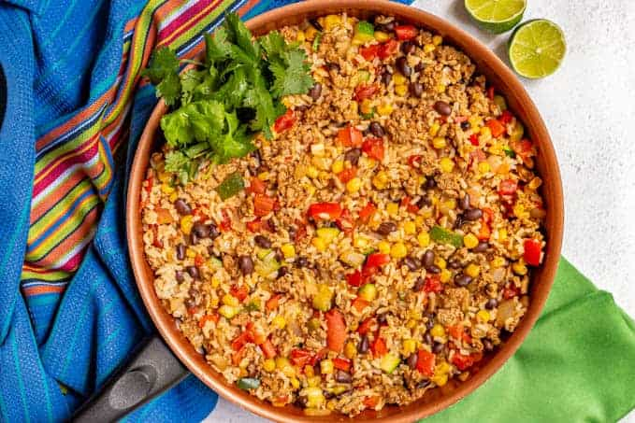
Serving size: 1 cup
Serves: 6

INGREDIENTS

1 Tablespoon canola or vegetable oil
1 medium onion, peeled and diced small
1 medium green pepper, diced small
1 medium red pepper, diced small
1 pound lean ground turkey or beef (90% lean), raw
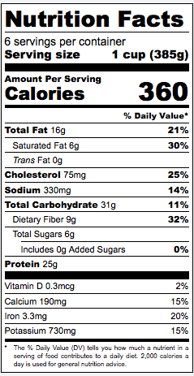
2 cloves garlic, finely chopped
1 teaspoon ground cumin
1 teaspoon oregano
2 teaspoons chili powder (no salt added)
1 (15 oz.) can low-sodium black beans, drained and rinsed
1 (28 oz.) can diced tomatoes, no salt added
1 cup canned low-sodium corn kernels, drained and rinsed
salt and pepper to taste
1 cup brown or white rice, cooked according to package directions and set aside
1 cup shredded cheddar cheese

PREPARATION
- In a large skillet, heat oil over medium-high heat.
- Add onion and peppers and sauté until softened.
- Add ground meat and cook until browned.
- Add garlic and spices and sauté until fragrant.
- Add beans, tomatoes and corn and bring to a simmer.
- Reduce heat to medium, cover with lid and simmer for 15-20 minutes until thickened, stirring occasionally.
- Remove from heat, add cooked rice and mix well. Adjust seasonings.
- Sprinkle with cheese and serve.

