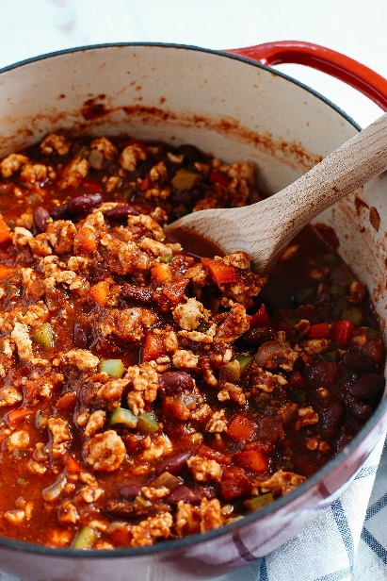


turkey chili with rice

A full meal that is made in one pot!

Add the veggies of your choice to customize this chili and make it your own.

Ingredients
1-pound ground turkey
1 medium onion, diced
1 teaspoon cumin
2 tablespoon chili powder
1-2 teaspoons salt
1-2 teaspoons pepper
3 cloves, garlic, crushed
1 carrot, diced (optional)
2 stalks celery, diced (optional)
1 green bell pepper, diced (optional)
1 jalapeno pepper, diced (optional)
1 cup instant rice or regular white or brown rice
2 cups water or chicken broth
2, 14-ounce cans tomato sauce, low sodium if possible
2, 14-ounce, can beans, no salt added (any type of bean, like pinto, kidney, or black bean)
1 can corn, drained

Instructions
- In a pot large enough to hold chili, brown the ground turkey. No additional fat or oil is needed if using ground turkey from the food pantry. Break into small pieces while browning.
- Add onion, spices, salt, and pepper. Mix and sauté until onions soften.
- Add garlic and other optional vegetables, if using. Mix and sauté until vegetables soften.
- Add instant rice and water (or chicken broth). Bring to a boil. Cover and simmer for 5 minutes. (If using regular rice, add liquid ingredients first. Bring to a boil. Then add rice, cover, and cook for 20 minutes or until rice is soft.)
- Add beans, corn, and tomato sauce. Bring back to a simmer. Cook for 15 minutes or until chili is thickened, stirring occasionally. Taste and adjust for seasonings. Enjoy!

Recipe featured in the November 2020 issue of
Beyond Hunger's Nutrition Newsletter



