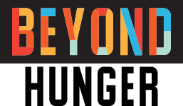

Volunteer Consent Form

I acknowledge that I have received the following COVID-19 vaccination policy for Beyond Hunger.
My signature below indicates that I have read and understand the statements within the COVID-19 Vaccine Policy and will follow the current protocols set forth by Beyond Hunger. I understand that it is my responsibility to read and comply with this policy. I further understand that I should consult the Volunteer Talent and Inclusion Manager regarding any questions raised by this policy.

FOR THOSE WITH MINORS: If only one chaperone, parent or guardian signs these forms on behalf of a minor volunteer, then the undersigned chaperone, parent or guardian of the minor Volunteer hereby covenants, warrants, represents and agrees that he or she is executing these forms on behalf of, and as an agent for, any other individual who may be a parent or guardian of the minor volunteer, that he/she is fully authorized to do so, and that by executing such Volunteer Release form, the undersigned is binding himself/herself, the Volunteer and any other parent or guardian of the Volunteer, and all of their heirs, next of kin, assigns and legal representatives to such Release.

Date: ________________

Volunteer name (Print clearly):
Volunteer name of minor (if applicable):

Volunteer signature
(Parent/Guardian):

